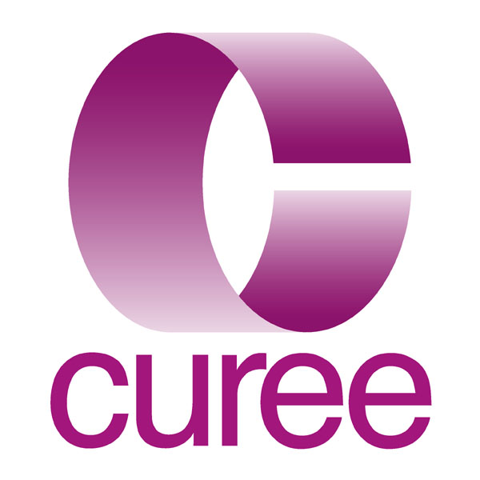
Knowledge Management Co-ordinator/Manager

Our organisation and its work
The Centre for the Use of Research and Evidence in Education (CUREE) is an independent development and research organisation at the leading edge of knowledge management in education. We work with a range of individuals and organisations, mostly in the public sector. Our market ranges from government departments and agencies to a heterogeneous mix of individual and groups of schools, colleges and local authorities. To them, we provide consultancy, research, knowledge resources and professional development to help them use research and evidence to improve professional practice. CUREE’s clients include the Training & Development Agency for Schools, the Learning and Skills Improvement Service, the National College, the Department for Children, Schools and Families, the General Teaching Council for England and the Qualifications and Curriculum Development Agency as well as a wide range of schools, colleges and local authorities. Our work, which covers the full spectrum from early years to Post-16, continues to expand and diversify.

Our products and services now include:
- finding, appraising and summarising ‘useful’ research and presenting it to the practitioner and policy communities in attractive printed forms as web resources and through blended learning tools and activities for use in schools and colleges;
- using our extensive knowledge of professional learning and coaching and mentoring to develop an ever expanding portfolio of tools and resources. We produced the National Framework for Mentoring and Coaching and, based on it, an innovative suite of rich media resources on coaching and mentoring. We deliver commissioned professional development programmes and/or make key note contributions to events organised by others. Most recently, we produced a customised pack of rich media resources for 14-19 practitioners in schools and colleges;
- a growing portfolio of research and evaluation projects ranging from systematic and technical reviews of research through to longitudinal evaluations of development programmes;
- support for and promotion of innovation in teaching and learning practice. This takes the form of R&D projects, consultancy and, increasingly, direct professional development.

Examples of current projects include:

Effective Mentoring and Coaching: Leading Development to Make a Difference
CUREE has created a series of 6 interactive packs for facilitators of CPD, drawing from a robust and extensive research and product background in both CPD and mentoring and coaching. Each pack is designed to be tailored and personalised by the CPD facilitator, enabling them to construct their own mentoring and coaching programmes to meet the needs of specific groups.

Building the Evidence Base for the 21st Century Curriculum
The project includes four activity strands focused on exploring successful approaches to the obstacles to progress which schools are encountering.

The Qualifications and Curriculum Authority (QCA) has the aim of developing a modern, world-class curriculum that will inspire and challenge all learners and prepare them for the future. QCA wishes both to uncover and build the evidence base for its development work on the curriculum and to devise and implement processes for the diffusion and use of the evidence amongst policymakers and practitioners.

The project is creating an alternate year cycle of pupil and school surveys complemented by research maps, bounded research-reviews, probes and action research in order to facilitate more differentiated and targeted monitoring. This approach will also enable the evidence gathering process to be related to the needs and interest of practitioners

The creation of the Research for Teachers (RfT) web resource hosted by the General Teaching Council for England (GTCe)
This comprises summaries of major, cornerstones studies telling the story of key findings and hot linking those findings to related research by classroom teachers. Implications for classroom practice are identified as are gaps in the research. RfT features are also complemented by a series of micro enquiry tools (research tasters) and a series of CPD activities that practitioners can use in departmental and phase meetings to sustain reflection on the implications of research for practice.

Have a look at our website (www.curee.co.uk) for more information about us and what we do.

The people
CUREE has a small core team based in Coventry extended and enhanced by a number of associates, some of whom are long standing contributors integrated into the team. At any one time, CUREE is about 24 strong. Associates are home based in the main. As a small group we need little formal internal structures or hierarchy. For operational purposes the staff are loosely grouped into two clusters; ‘content’ and ‘infrastructure’. CUREE will generally be working on around 12- 18 projects at any one time and a project team will be put together to work on that project. Projects usually have a director and a co-ordinator. Team members will typically be working in two or three project teams at any one time.

Most staff are graduates; many have post graduate and specialist qualifications. Most have a professional background in one or more of teaching, research, policy, information science, journalism and marketing. We pride ourselves on our commitment to learning (other people’s and our own) and our flexibility; of the staff and their response to new challenges, and of the organisation in accommodating family friendly working patterns. People might join us with very specific skills or experience but we expect them to become multi-skilled and we are committed to helping them become so. No-one says ‘I can’t do that’ but someone might reasonably say ‘I can’t do that yet’. We are serious about practising what we preach; about living out our company values (http://www.curee.co.uk/block-content/statement-values).

The Job
CUREE’s business is the manipulation of information – gathering, sifting, processing and refining it so that it is useful to our clients. We collect information and we make knowledge which we share with others. Everybody’s job in CUREE involves some knowledge management but one job has the management of knowledge as its primary purpose – and this is that job. It has elements of research librarian about it (though most of the ‘stock’ is digital) and a lot of data management. We currently use a range of data management and other IT tools including Access, Drupal, Knowledge Tree, Minitab and Nvivo. The list below gives a bit more detail about the range of responsibilities.

Co-ordinator level

- designing and refining search and retrieval processes to harvest relevant research from a wide range of online (and hard-copy) sources;
- extracting and managing data on relevant research from electronic databases and other published sources using search engines, query tools and other more traditional approaches;
- coordinating a current awareness service;
- designing, constructing and maintaining in-house databases of relevant material, including library catalogue;
- designing, or helping others to design, research data retrieval, storage, and analysis techniques and tools to support primary and secondary research activities
- providing a referencing service and advice to other team members and occasionally to clients;
- designing and carrying out searches for systematic reviews;
- producing technical reports and research briefings;
- coding, entering and editing data in a variety of database formats;
- contributing to the design of client databases;
- maintaining a collection of physical (books, articles etc) and digital resources; and
- advising on the management of Intellectual Property Rights.
- coordination of one or more projects, especially ones with a substantial knowledge management component.

Additional responsibilities of Manager level (depending on qualifications and experience)

- supporting the Managing Director in the development of CUREE’s overall knowledge and information management strategy
- contributing to briefing and training sessions for other CUREE staff and occasionally clients’ personnel;
- analysing research and writing summaries of research/evidence in an appropriate style and language for a practitioner or policy maker audience; and
- critically appraising research reports, articles and proposals;
- writing text and web summaries of research for a variety of audiences including teachers and policy makers;
- developing digests of substantial pieces of research including systematic reviews and books;
- synthesising across a number of research studies to draw out messages for a variety of audiences;
- collating and co-ordinating comments on research reports;
- participating in the overall management and co-ordination of CUREE’s ICT infrastructure;
- participating in conferences, seminars and training workshops;

All staff are expected to work collaboratively as part of a team and to undertake other duties appropriate to their post’s grade and nature.

Terms and Conditions
This is a full-time post with normal hours of 37.5 per week, although flexible working would be considered for the right candidate. Holiday entitlement will be 28 days per year (rising to 33 after 5 years) including Bank Holidays. Starting salary will fall within the range £18,000 to £28,000 depending upon experience, skills and knowledge of the appointed candidate.

The company has a designated Stakeholder Pension Scheme, to which it makes a matching contribution of 4%.

We provide active support for continuing professional development, including the acquisition of relevant further academic and professional qualifications.

Person Specification
 | Essential | Desirable
Qualifications | - first degree (or similar), preferably in an analytic discipline | - Post-graduate qualification in information science or librarianship
Knowledge of | - online discovery and retrieval systems  - general principles and specific applications of the organisation of information (including concepts such as taxonomies, dictionaries and glossaries, meta-tagging and standards)  - general understanding of the principles of data analysis and relational databases in particular  - database management and interrogation systems such as Access  - online data repositories  - content management systems | - the relationship between corporate objectives and knowledge management  - the sector specific knowledge management issues arising from education research  - education specific databases and resources (journals, CPD resources etc)  - the application of Web 2.0 technologies to information management (e.g. wikis, folksonomies)
Experience of | - administration and self-organisation  - undertaking research or enquiry  - working in an office environment  - using well designed search terms to retrieve relevant data from online data repositories  - self-directed collaboration with others towards a pre-defined goal | - supporting the knowledge management needs of a small research related organisation  - project management  - working in a collaborative environment under strategic direction  - writing for a variety of audiences  - working (paid or unpaid) in an educational environment
IT Skills | - word-processing, email and file management  - spreadsheets  - database management  - sourcing information using the web and/or web-based databases | - PowerPoint  - MiniTab  - Nvivo  - Knowledge Tree
Skills & attributes | - ability to analyse problems or information systematically and in depth  - ability to take initiative and responsibility for your work  - an openness to new experiences, an enquiring approach to what you know already and a eagerness to learn more  - good written and oral communication skills  - organisational skills – of yourself and of others  - ability to contribute effectively as part of a team  - flexibility and multi-tasking  - optimism, cheerfulness and an interest in other people | - ability to make connections between ideas and projects, between theory and practice  - ability to function with strategic rather than day-to-day supervision  - ability to take the initiative in recognising a problem or need and to indentify practical solutions  - capacity for honest reflective self appraisal  - persuasive interpersonal skills  - ability to understand/put yourself in the shoes of customers, readers, learners and colleagues  - advanced written and oral communications skills

