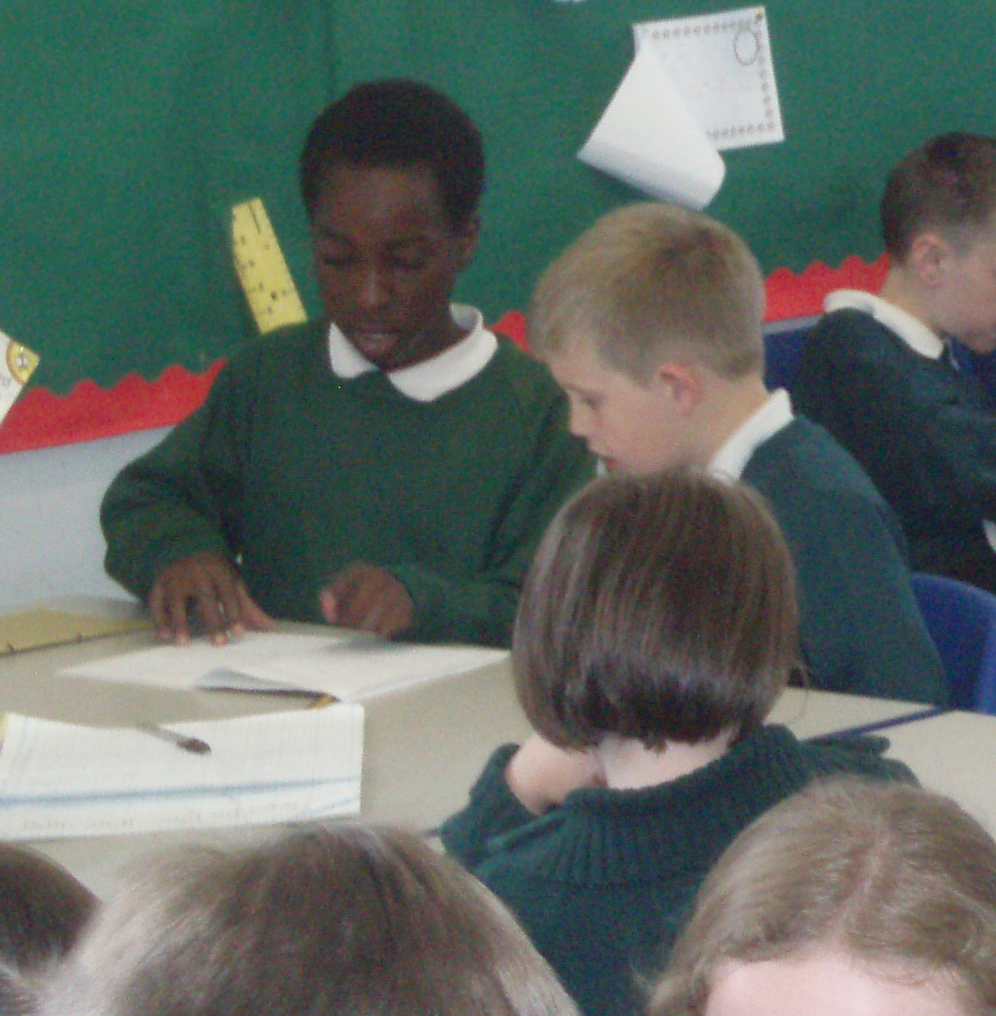

Transition and beyond: Moving forward together

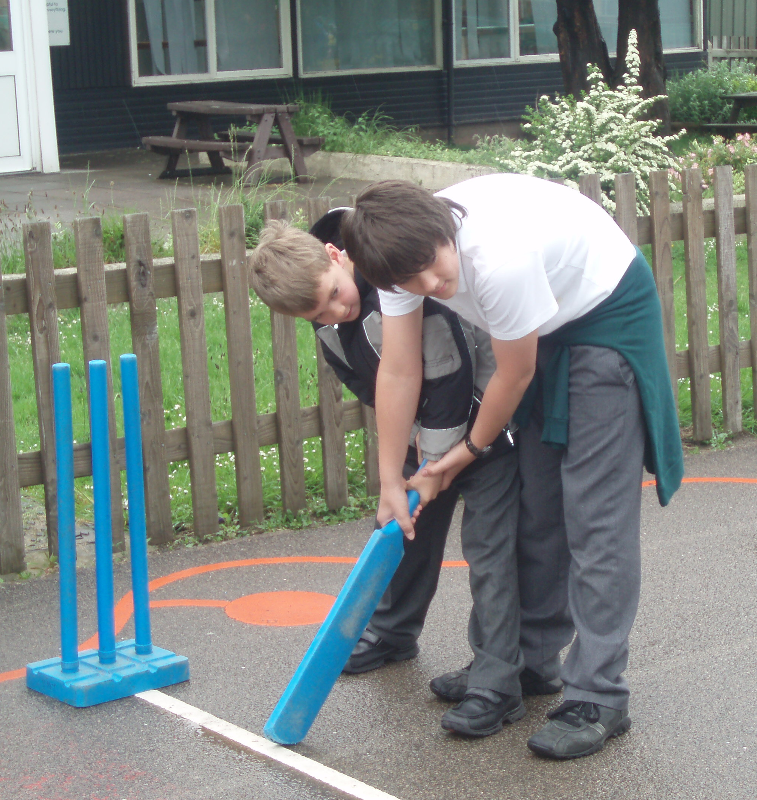

Aims of the project

The aims of this project were to explore issues about KS1 to KS2 transition, to develop a more integrated approach to transition and to create greater consistency among staff in the Key Stages of each side of transition in relation to judgements about pupils’ attainment at the end of Key Stage 1.

Dimensions of the study

Broadmeadow Junior School is a larger than average junior school (260 pupils) situated in Birmingham. It has high levels of social deprivation, with around one in three pupils entitled to free school meals. Approximately 20% of pupils are on the special needs register (in line with the national average). Most children live locally in rented council property. The majority of the children are white British (206); the remainder of the children are from other ethnic backgrounds. The project ran over a period of 12 months and involved a range of people including:
- head teachers of the Infant and Junior schools;
- three Year 2 and four Year 3 teachers;
- 258 Year 3-6 and 48 Year 2 children;
- all Parents of Year 2 and Year 3 children; and
- the Governing bodies of both schools.

Summary of main findings

The main findings from this project were:
- The initial perception of Year 3 teachers was that Key Stage 1 SATs results were over-inflated and children were moving into the Junior School with unrealistic levels which led to over-ambitious targets
- The inquiry process was a valuable mechanism which supported staff in developing greater empathy for, and knowledge about, each other’s context. The new project transition arrangements have helped to improve pupils’ experiences of moving from the Infant School to the Junior School
- The ‘transition unit’ developed by the project helped to establish some common approaches across the Key Stages

Background and context

The school is part of soft federation with the co-located Infant School. However, communication between the two schools has been limited, with both schools working relatively autonomously. Recent history, including the Junior School falling into an OFSTED category (Serious Weaknesses 05-06) due to low value added, had led to a difficult relationship between the two schools particularly in the areas of standardised assessment and transition. While individuals were cordial and professional, relationships remained somewhat distant and there were few opportunities for collaboration. Changes in senior management have provided an opportunity to develop closer working links; both schools view this as a positive development.

The project was guided by three overarching inquiry questions:
- How do different groups within the Infant and Junior schools perceive KS1 to KS2 transition?
- What changes could be put in place to improve:
- teachers’ assessments of children’s current levels; and
- the consistency of teachers’ and pupils’ expectations across Key Stage transition
- To what extent has the process promoted a greater understanding between Year 2 and Year 3 teachers?

Processes and strategies

The project involved a number of processes and strategies, including:

- Joint meetings between the schools
The head teacher and deputy head teacher of the Junior School and the head teacher and a senior teacher from the Infant School formed the working party for the research. They met formally on a monthly basis. The purpose of these meetings was to shed light on long-standing and emerging issues, to reflect on progress and to formulate strategies to improve practices associated with effective Key Stage transition.

- Views of participants
Children, parents and staff perceptions were gathered to assess their views and attitudes towards transition and capture their ideas for improving the current arrangements.

- Key Stage 1 children visited the Junior School
Children were invited over to the Junior School for an afternoon with their new teacher; they shared some playtimes with the Junior children. The Year 6 pupils shared guide books they had made for the children. The guide books contained details about the school with advice for their younger peers. Year 2 and Year 3 children visited each other’s classrooms to help alleviate concerns about the transition the younger children had.

- Teachers from both Key Stages jointly marked and moderated Key Stage 1 SATs
The teachers held differing perceptions of the levels children were working at. The project has challenged this variation in assessment practice. Year 3 teachers observed the delivery of SATs tests and shared marking and moderation of pupils’ answers with their colleagues from Year 2, using the official marking scheme.

- The transition unit
The project aimed to improve transition through the curriculum, too, and to give children a feeling of continuity and confidence in their new setting. A cross curricular unit of work was developed jointly by Year 2 and Year 3 staff led by the Junior deputy and the Infant senior manager. This unit of work, based on Beatrix Potter, was started in the final two weeks of Year 2 and was continued for the first two weeks of Year 3 in the Junior School. It formed the basis of all lessons apart from maths. The activities included:
- comparing the differences between London and the Lake District in geography;
- researching the life of Beatrix Potter in History;
- creating a series of animal images in ICT;
- writing in the style of Beatrix Potter in Literacy;
- researching the life of St. Francis of Assissi in RE;
- comparing different kinds of building materials in Science; and
- an opportunity to handle a number of NIMls brought to the school by a visitor.

The children made books and posters which they use to create displays around the school.

- Sharing of Junior School behaviour policy with a view to developing a joint Junior and Infant policy
This element of activity is ongoing. To date, there have been joint meetings and discussions and plans remain in place to generate this policy.

The findings

The inquiry process was a valuable mechanism which supported staff in developing greater understanding of each other’s context. Staff in both schools had previously had limited understanding of the pressures and challenges faced in each other’s settings.

The project provided a structure and process which has facilitated a climate of honesty and a willingness to change through open discussion. The Junior School head teacher reflected;
“The action research project has already brought about a positive influence on the two schools. We will continue working closely and moving forward together towards common goals.”

The head teachers of each school and other key teachers now work together much more closely and have established supportive relationships which enable them to discuss and address sensitive issues.

The project challenged the variation in assessment practice and established a rigorous process for marking and moderating Key Stage 1 SATs levels.
The working party scrutinised a sample of books from pupils who had newly entered Year 3. They identified a wide variation in judgement between teachers from the two Key Stages. One Year 3 teacher stated:
“There is sometimes a massive dip, which can be as much as two or three sub levels below Key Stage 1 SATs results and the firstJjunior assessment – this seems extreme”.

This finding had a number of implications for the organisation of children’s learning in the Junior School. One Year 3 teacher commented on the difficulty in grouping children according to their SATs results;
“SATs results often don’t match what the child is capable of doing, especially when working independently.”

The Year 3 teachers also reported that on some occasions this had affected children’s self-esteem because they had to change groups in order to be able to access the appropriate level of work.

The perception of the Year 3 teachers at the outset of the project was that the SATs results were over-inflated and children were moving into the Junior School with unrealistic levels which necessitated the setting of over-ambitious targets. Staff in the Junior school consider the joint marking and moderation has had a positive impact on the accuracy of Key Stage 1 SATs results. This term, Year 3 class teachers have reported that pupils’ levels appear to better reflect the pupils’ capabilities and this has allowed the Junior School to set challenging but attainable end of Key Stage targets. The head teacher reflected:
“This year we appear to have had a truer starting point for our Year 3 children so we’ll be able to demonstrate an accurate picture of our valued added.”

Following the working party’s book scrutiny it became evident that a consistent approach to layout and marking would be advantageous. There were clear inconsistencies in expectations of presentation and layout of work across the two Key Stages which needed to be addressed.

As a result of the project transition arrangements have been changed. This improved pupils’ experiences of moving from the Infant School to the Junior School.
In order to improve pupils’ experiences of transition, Year 3 teachers were given opportunities to work more closely with their colleagues in the Infant School. The changes to transition arrangements have had a positive impact across both schools. One parent commented:
“[the] new system in place is a lot better and leaves children feeling secure and happy about transition”.

And another reported:
“The changes were lovely this year. The children were given more of an opportunity to spend time with the Juniors, which enabled the children to adapt to the changes”.

While a third reported:
“It all seems to be really well planned and as a parent I feel really pleased with all the preparation which has gone into making the transition successful”.

As a result of working on this project the deputy head of the Junior School reported:
“The children have come into Year 3 much more settled this year. It has made a difference, the books, the transition unit, it has all helped, even having time in the playground has meant they’re less nervous, more excited and looking forward to coming up rather than feeling wary about it”.

The new transition unit designed by the teachers helped teacher and pupils establish common approaches to learning as they underwent transition.
The project aimed to improve transition through the curriculum and to give children a feeling of continuity and confidence in their new setting. The children engaged with the transition unit both in the Infant School and when they got to Junior School. A new parent remarked;
“I feel that the whole transition process has been very smooth and the Beatrix Potter project should see a huge return for the children”.

Research methods

Data were collected from a range of sources using a variety of methods, including:
- children’s views were gathered using a variety of methods – circle time, group discussion, teacher-led discussion and concept mapping;
- Year 3 parents were sent a questionnaire at the start of the project. 8 out of a possible 78 were returned;
- Year 2 parents were given a presentation about the project and an evaluation sheet at the New Parents Morning in the Junior School; and
- teachers’ views were gained through professional discussions and questionnaires.
Data collection and analysis informed each other. We analysed all of the data to identify key themes, issues and patterns which emerged during the inquiry. This involved collating and analysing survey results, re-listening to taped interviews and re-reading written notes and other documents to identify reoccurring key themes within and across datasets.

Conclusions

The project had a positive impact in three broad areas:
- Curriculum
- School community experience of transition
- Professional practice

These outcomes raise a number of interesting issues relating to:
- Using iInquiry for school improvement
- Junior-Infant School collaboration
- Key Stage 1-2 transition

Using Inquiry for school improvement
Our reflections led us to consider whether inquiry could be developed further to improve continuity of curriculum coverage and practice across Key Stages through:
- team teaching and liaison between Junior and Infant co-ordinators; and
- joint Continuing Professional Development across both Key Stages.

Junior-Infant School collaboration
We began to think about structures and processes for sustaining communication and collaboration between Year 2 and 3 teachers including:
- senior teams working together to develop a joint vision for the two schools underpinned by consistent policy documentation; and
- effective ways in which staff in the two Key Stages could work together, with the aid of other external agencies, to support collaboration across the Key Stages.

Key Stage 1-2 transition
We have now begun to ask questions about how we can make transition more personalised for the pupils, including:
- How can we best identify the specific learning needs of pupils at the end of Year 2 and how can we best meet them at the beginning of Year 3; and
- How can we support parents to meet these needs in the interim time, prior to their children joining the Junior school?

Suggestions for further reading

Ensuring a smooth transition from KS1 to KS2
http://www.teachernet.gov.uk/casestudies/casestudy.cfm?id=333

Primary National Strategy Guided reading: supporting transition from
Key Stage 1 to Key Stage 2
http://www.standards.dfes.gov.uk/primary/publications/literacy/63489/nls_trans_guidedread006403.pdf

The Impact of School Transitions and Transfers on Pupil Progress and Attainment
Maurice Galton, John Gray and Jean Ruddock
http://www.dcsf.gov.uk/research/data/uploadfiles/RR131.doc

Authors’ contact details

Ms J Matthiae, Head Teacher; Mrs G Gaynor, Deputy Head Teacher
Broadmeadow Junior School
Monyhull Hall Road
Kings Norton
Birmingham
B30 3QJ
TEL : 0121 464 1717

