Visual Awareness Strategy

Aims of the Project

To improve children’s confidence and engage disaffected pupils (boys in particular) through the teaching of a Visual Awareness Strategy (VAST©), as a third ‘visual’ tool with which to express themselves across the curriculum. To instruct teachers in VAST strategies and Action Research Methods to enhance their own teaching through the use of a visual awareness strategy across the curriculum.

Context

The VAST pilot study involved a partnership between secondary, middle, primary and early years educational practitioners. Teachers and classroom assistants of three age groups (3, 4 and 8/9 years) worked collaboratively with Myers (secondary school teacher) in the development of a new and innovative pedagogy to reduce disruptive classroom behaviour (DCB). In all 160 children were involved in the study; 80 children receiving the VAST intervention and 80 not receiving VAST training (‘control groups).

Summary of Main Findings

- Children’s drawing showed a considerable improvement
- An improvement in the quality of drawings and the time span (concentration) taken to complete the observational drawings in the 3-year-old (particularly in boys) and 4-year old pupils.
- Individual teacher research projects all had successful outcomes for groups where Visual Awareness Strategy was being deployed compared with other groups. In one study a group of four-year old children which was taught using VAST learnt more of the phonic alphabet than the ‘control’ group. A second group of three year old children learnt to share their belongings and thoughts, while the ‘control’ group fared far less well. In an 8/9 year old study the VAST group coped with fractions better than the ‘control’ group.
- The teacher interviews indicated.a fair improvement in behaviour was noted among the 4-year–olds but little difference in behaviour amongst the 3- or 9-year-olds.

Background to the Pilot Study
The intention of this VAST pilot study was to establish if, by giving children confidence in their ability to express themselves visually and spatially (children who may arguably have had an inability to achieve success with learning through traditional teaching methods), there would be fewer incidences of low-level disruptive classroom behaviour. We also hoped that the individual teacher action research projects would extend understanding of how VAST techniques can be applied across the curriculum and so boost teachers’ confidence in using and giving instruction in VAST techniques. Teachers, classroom assistants and pupils in one pre-school (age 3), two primary school reception classes (age 4) and one middle school Year 5 class (age 9) were the participants of the pilot study.

Processes and Strategies
The VAST pilot study involved a partnership between secondary, middle, primary and early years educational practitioners. VAST is concerned both with teaching children how to draw and how to use visual representation as a means of expression and as an aid to layout and presentation in all curriculum subjects. This pilot study, however concentrated on just one aspect (the first) of the programme, that of teaching children how to draw. An essential element of this VAST programme was the in-service training (INSET) in VAST techniques. This programme gave teachers confidence in their own drawing ability and confidence to instruct and guide their pupils in the VAST techniques.

The VAST techniques, which in themselves are simply taught, are as simplistic as the building blocks that lead from a recognition of letters to reading, or the manipulation of tens and units that lead to a mathematical problem solving ability. Pupils are taught how to ‘look’ at what exists around them and how to make representative images on paper through an understanding of line drawing and through breaking down the ‘observable’ into a series of relating shapes.

The VAST programme of lessons consisted of three fifteen minute sessions per week using the scheme of work from the text book Insight into drawing. The lessons began with teaching children how to draw straight and curved lines then moved onto a series of drawing and looking exercises based on a variety of different shapes, including shapes obscured by other shapes. Children were taught how to look for both the positive and negative shapes (objects and the space between objects). There followed an exercise in shading with colour. The shapes were then used to form a picture that the children shaded with colour. Next there was an exercise where children copied a picture by cutting out and placing shapes in the correct position - using only shapes they had initially drawn. This drawing was then shaded with colour copying from the original drawing.

The understanding of shapes links with the Foundation Stage programme and numeracy targets on shape in Year 1. Teaching observational drawing and presentation techniques enables children to better understand the world around them and leads to a third way of representing information. VAST is a transferable skill that can be used in all curriculum subjects (Myers, 1999, 2005).

Preliminary Findings
Among the 3-year-old and 4-year-old children there was a considerable improvement in drawing from the beginning to end of the programme. The 3-year-olds girls who had been taught VAST showed a greater improvement in drawing than the boys. However, the pre-school boys showed a greater improvement in concentration (as measured by the time they chose to spend on their drawings). The boys in the VAST group spent a mean time of 5.3 minutes more than the ‘control’ boys and 2.7 minutes more than the girls in the VAST group. Both 3-year-old VAST groups (girls and boys) achieved a greater improvement with their observational drawings than the equivalent ‘control’ groups.

The 4-year-old boy VAST group’s drawings showed a greater improvement over time than the girl VAST group and a considerably greater improvement over the boy ‘control’ group’s drawings. Both 4-year-old VAST groups showed a considerable increase in concentration, measured by the time they chose to spend on the drawings the second time, with both boys and girls averaging 23.4 minutes as against 3.4 minutes (boys) and 4.8 minutes (girls) for the first drawing. The length of concentration was greater in the VAST group than in the ‘control’ group. Figure 1 shows an example of the first and second attempts at the observational drawing exercise. All reported means were adjusted for age.

Figure 1. An example of one 4-year-old boy’s drawings at Observation 1 and Observation 2

Original drawing Observation 1 Original Drawing Observation 2
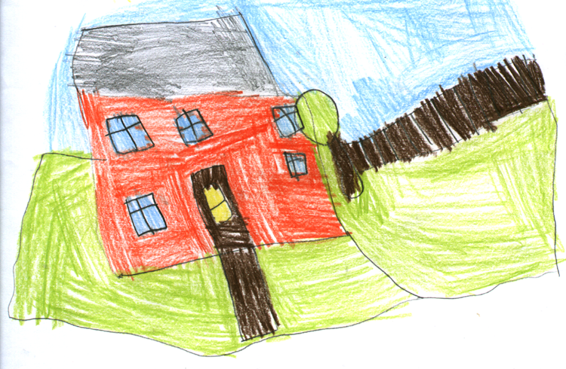
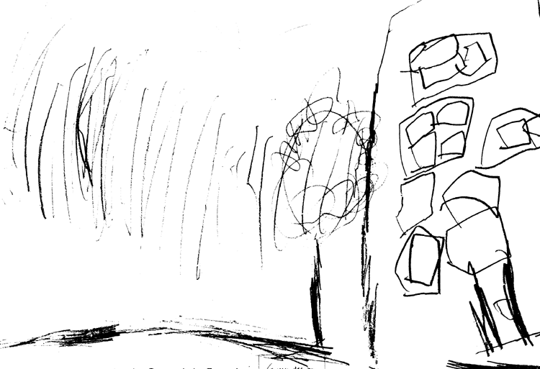

4-year-old boy’s drawing Observation 1 4-year-old boy’s drawing Observation 2

From the first attempt at drawing in Figure 1 it can be seen that the pupil has noted and copied some shapes, although not necessarily in their correct positions. From the second drawing, completed 9 months later, it can be seen that the pupil has now learnt to pay great attention to the ‘whole’ drawing as well as attention to small details, including the rendering of colour fairly accurately. These drawings are fairly representative of the progress made within the reception class ‘treatment’ group.

The 8/9-year-olds drawings told a different story. Not only did the VAST group’s drawings not improve over the ‘control’ group, but there was also less of an increase in concentration than in the ‘control’ group.

Research Design and Methodology
The small scale action research (AR) pilot study into the teaching of a visual awareness strategy (VAST) was conducted during the autumn and spring terms 2004/2005 in four schools on the Isle of Wight. Pupils in one pre-school (age 3), two primary school reception classes (age 4) and one middle school Year 5 class (age 9) were the participants of the pilot study. Matched ‘control’ group classes ensured that the findings of the study could be assessed with rigour.

The research design and methodology of the pilot study incorporated systematic classroom observations of both ‘treatment’ groups, which were taught using the Visual Awareness Strategy and ‘control’ groups which were not. By observing children over time we hoped to ascertain whether disruptive classroom behaviour (DCB) improved as a result. The Abikoff/Gittleman (1985) behavioural observation coding system was chosen as it was the only behaviour observation code appropriate for observing pre-school and reception class children in the classroom. A Research Associate (trained in social research methods), blind as to the identities of the VAST and ‘control’ classes, carried out the classroom observations. Children, randomly selected by number, were observed singly or in groups of two or three, and their ‘on-task’/’off-task’ behaviours noted down every 15 seconds on the pre-determined list of codings.
As an additional measure of changes in children’s behaviour, teachers used the Revised Rutter Teacher Behaviour Rating Scale (Hogg, Rutter and Richman, 1997a, 1997b) to assess any behavioural difficulties. Before the VAST study commenced, an individual report was completed for every child taking part in the study, whether they were in the VAST groups or not. Children’s behaviour was then categorised into five groupings: total difficulties; emotional difficulties; conduct difficulties; hyperactivity and inattentiveness difficulties; and prosocial difficulties. Towards the end of the study teachers completed a second report for each pupil. This scale was selected as it had ratings for both pre-school and primary pupils and was considered to be better for antisocial behaviours than for emotional behaviours (Elander and Rutter, 1996).

We also analysed observational drawing skills both at the beginning and at the end of the study. Both groups were tested by the author. The task was to copy a computer generated drawing. The children were asked to work at the task until they were satisfied with the result. The intention was not only to assess the drawings for improvement but also to assess whether children’s ‘concentration’ time improved. The drawings were assessed for improvement, qualitatively, by two Art teachers, blind as to the composition of the groups. Additionally drawing skills and concentration were quantitatively analysed by SPSS (mixed ANOVAS) based on an Art teacher’s raw scores out of10 for the drawings both before and after the teaching of VAST and a comparison of the length of time taken to complete these two drawings.

Conclusion
Teachers engaged in this VAST programme were taught the techniques of drawing themselves, and how to teach these techniques to their children. Hence they became more confident in teaching observational drawing. This became evident during an observational drawing trip made by the pre-school children and their teachers. Armed with paper and clipboards the children went on an expedition to draw local houses.

To sum up, therefore, this short pilot study has already shown that children attending VAST programmes have improved their observational drawing and powers of concentration (particularly in pre-school boys) and it is anticipated that in the studies presently underway (and planned for next year), there will be a noted improvement in disruptive classroom behaviour.

Reasons for the 8/9 year olds showing a smaller improvement in drawing and concentration over time than the ‘control’ group may have been because they followed the programme for only half of the time spent by the 3- and 4-year-olds, or, that the pupils were too old for this preliminary VAST element which had been designed primarily for younger children.

What is happening now
The second element of the VAST presentation and drawing techniques are being introduced to class 1 teachers of Green School who are now teaching the reception class pupils involved in the pilot study. At the end of the 2005/2006 academic year the children’s work will be assessed by the same (modified) data gathering instruments as in this pilot study.

A VAST intervention is currently in progress at a 13-18 high school with Year 9 pupils. Interim findings show that VAST is effective in part. Further studies with a variety of age groups are planned for 2006/2007. This is consistent with the view that a creative framework to the curriculum ensures all children will receive an education that is “…good for the economy and therefore good for society.” (Craft, 2003, p.115).

Suggestions for further reading
Abikoff, H., Gittleman, R. 1985. Classroom Observation Code. A Modification of the Stony Brook Code. Psychopharmacology Bulletin. 21(4), 901-908.
Cohen, L., Manion, l., Morrison, K. (2000). Research Methods in Education. London: Routledge Falmer.
Elander, J., Rutter, M. 1996. Use and Development of the Rutter Parents’ and Teacher’ Scales. International Journal of Methods in Psychiatric Research. 6, 63-78.
Green, L., Mitchell, R. 1998. The Effectiveness of an Initial Teacher Training Partnership in Preparing Students to Teach Art in Primary School. International Journal of Art and Design Education. 17 (3), 245-254.
Hogg, C., Rutter, M., Richman, N. 1997a. Revised Rutter Teacher/Nursery Staff Scale for Pre-School Children. In I. Sclare (Ed.) Child Psychology Portfolio. nferNelson: London.
Hogg, C., Rutter, M., Richman, N. 1997b. Revised Rutter Teacher Scale for School-Age Children. In I. Sclare (Ed.) Child Psychology Portfolio. nferNelson: London.
Myers, W.R. (1999). Insight into Drawing. Northants: First and Best in Education Ltd.
Myers, W.R. (2005). Dissertation submitted to the University of Portsmouth in partial fulfilment for a PhD.
Pavlou, V. (2004). Profiling Primary School Teachers in Relation to Art Teaching. International Journal of Art and Design Education. 23(1), 35-47.
Robson, C. (1999). Real World Research. Oxford: Blackwell.
Somekh, B. (1989). Action Research and Collaborative School Development. In R. McBride (Ed.), The In-Service Training of Teachers (pp. 160-176). Lewes: The Falmer Press.

Author and contact details

Wendy Myers
Teacher/Researcher

Sandown High School, The Fairway, Sandown, Isle of Wight, PO36 9JH
email: wendymyers@nasuwt.net

