Does using voting sticks technology enhance teaching and learning?

Aims of the project
To assess the impact of voting sticks technology in terms of:
- engaging hard to reach learners;
- creating interactive learning resources across the curricula; and
- assessment.

Dimensions of the study
Bedfordshire Adult and Community Learning (ACL) offer a broad selection of classes for adults in over 200 venues across the county. This project is focused on classes for Modern Foreign Languages (MFL), Skills for Life (SfL) including probation (OLASS) learners, Information Communication Technology (ICT) and Preparing to Teach in the Lifelong Learning Sector (PTLLS). This project is in line with the ILT strategy and the Post Inspection Action Plan for Bedfordshire. The project involved a team consisting of an ICT tutor, a MFL curriculum manager and a Skills for Life programme manager. Each used the voting technology in their area of expertise and gathered feedback from learners.

Summary of the main findings
- For tutors the technology was simple to set up and use (after initial teething problems were ironed out)
- The resources were easy to create and it was simple to adapt existing resources.
- Learners found the interactivity fun and engaging
- Learners were reassured by the anonymity to express an opinion
- Tutors found the reporting facilities within Quizdom helpful for generating both group and individual reports

Background and context
Voting technology has never been used as an e-learning tool in Bedfordshire ACL. However, voting sticks were used by Senior Management at the Annual Tutor Conference this year to involve the tutors in identifying the goals of the service. It was clear that this was an excellent way to engage people and was fun. It also gave more innovative tutors idea that there was potential to use this as a classroom resource to assessment and induction. It evoked a lot of interest and tutors expressed the view that voting technology could enhance teaching and learning. One tutor working with the probation service believed that it could be a way of engaging some of the difficult learners. Another believed that it could be a painless, paperless way to carry out the first night induction. It was seen by the MFL manager as a possible method of doing initial assessment to gauge the entry skills level of learners at the beginning of a course. Following consultation with curriculum managers and programme managers a consensus emerged that action research could help us answer the question ‘Does the use of voting sticks enhance the teaching and learning experience?’ In order for tutors and learners to ‘buy in’ to new technology it had to be simple and deliver some value.

Research has been carried out into the technology available and some useful information on the Subject Learning Coach e-electives community Moodle site led us to arrange a demonstration of the Quizdom voting sticks technology. We agreed that this tool could be used in a variety of ways to enhance the learners’ experience and decided to follow the helpful demonstration up with a training session for staff when the voting sticks are delivered.

The use of voting sticks supports the constructivist approach described by Laurillard's framework which includes four important components: teachers’ concepts, teachers’ constructed learning environment, students’ concepts and students’ specific actions (related to learning tasks). We hoped the voting sticks would be a fun way to generate discussions and interactions and that the anonymity of learners using the voting technology would faciliate the engagement of learners that may be reticent to participate in group discussion.

Processes and strategies
The Quizdom voting sticks use software called Actionpoint which is based on PowerPoint with an additional toolbar to either create or adapt existing PowerPoint presentations, for which training was required. Our approach was to initially train those using the technology for the research project and then cascade it via curriculum managers to tutors. Tutors were self-selected for this action research project and all attended a training session provided by the supplier of the voting sticks. Tutors peer coached and supported one another throughout and continue to do so. The technology has been used in a variety of ways;
- to replace form filling at induction;
- to establish tutor training needs;
- for formative assessment; and
- to make Maths quizzes fun.
Each tutor could adapt Quizdom to meet the needs of the group; decide whether to give feedback via the handset, whether to allocate names to handsets or allow participants to be anonymous and whether to use demographics or put learners into groups.

There were inevitably some teething problems with using new technology. The training for staff was delivered in July and the equipment was not used until September. So a ‘catch up' session was held in early September to enable tutors to practise using the equipment in a supportive environment. The session involved some coaching and support by sharing resources.

The findings
Once the initial problems were overcome the feedback from both tutors and learners was positive. Tutors used Quizdom for induction of a Skills for Life class; a PowerPoint was created that gave all the information required for induction and the quiz at the end of the presentation checked that learners were informed of their rights and responsibilities as learners. The feedback from both learners and tutors was that the presentation gave structure to the induction and the quiz allowed learners to answer honestly. The main benefit was seen as the reduction in form filling as the report created using the technology gave all the information required for administration purposes. An unexpected outcome was the group bonding and communication about the quiz. When learners were completing forms at induction in the past the tutor only saw the tops of the heads of learners; with Quizdom the tutor was able to see their faces and engage with them. The entire process was an excellent ice-breaker rather than a dry start to the course with information overload and paperwork to complete.

The reporting system within Quizdom was impressive and there were a range of options. Primarily the choice was about the format of reporting you prefer; CSV or Flash. (See below examples of both CSV and Flash.) There were many options with the reporting process, such as showing or not showing questions, displaying group or individual results, to show or not show answers, style of chart used etc.

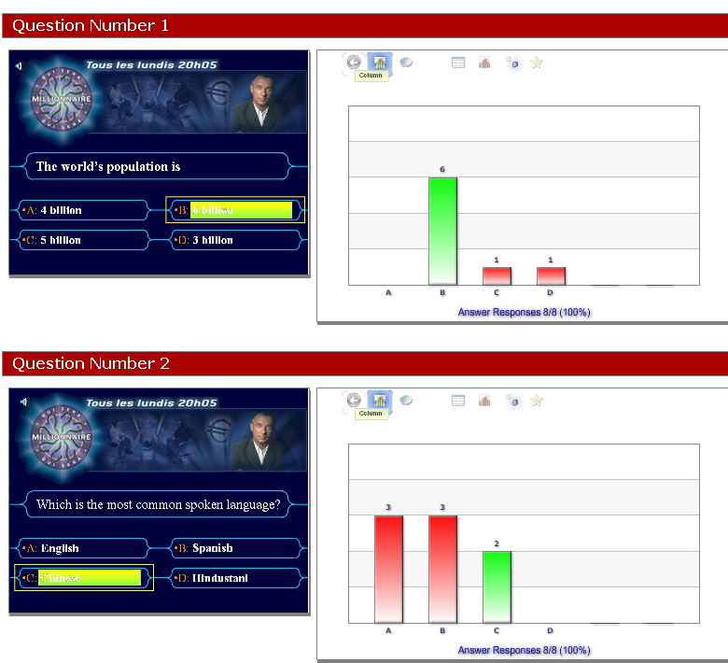

All tutors reported that they felt real engagement on the part of the learners and that having used Quizdom they can see its potential as a tool for formative assessment. It was agreed that this research should continue in order to assess the outcomes of the course regarding retention and achievement.

A version of ‘Who wants to be a Millionaire’ was demonstrated to tutors, who then used the voting sticks to answer. All tutors were enthusiastic about using voting sticks in MFL – they are fun and easy to use. They could be used not only for a programme like Millionaire (which in itself has many uses, from practising grammar to cultural questions). Quizdom has the facility to mark homework, as learners can input their answers the next week and the tutor can then generate a report. The technology can be used for multi-choice questions for listening comprehensions. Tutors were all agreed that the anonymity in using them (as far as fellow learners are concerned) could encourage learners could take part in any activities using them.

A quote from the MFL tutor after using Quizdom “The writing of a new presentation quiz proved easy, as was the use of an existing presentation, which readily adapted itself to multi-choice questions”.

At the first class of a new MFL course, with 13 learners present, the sticks were used to get feedback after the learners’ induction. Did they know where the fire exits are/did they understand what the course was about/did they feel the course was for them etc. All stressed the fun element and liked the fact that the replies were anonymous (although the tutor is able to identify learners). From the tutor’s point of view, it provided an easy way to get feedback from all learners, even those who would normally not want to give their opinion in front of the class, and it brought a fun element to a serious part of the course, induction.

Research methods
The data collected were mainly in the form of oral feedback from tutors and learners. Other data were collected using software that was part of the technology. As the project continues we plan to collect feedback from tutors and learners through standardised questionnaires to be delivered through the technology. The questions will focus on a number of features including:
- Were the equipment and software easy to use?
- Was the equipment reliable?
- Can resources be easily adapted?
- Do learners engage with the technology?
- Is equipment portable and easy to set up in a variety of locations?
- Does this technology support assessment?
- How did using the technology impact on learning?

The questionnaire will be developed using the Quizdom software and will be carried out during the project with learners and post project for tutors and managers.

We will run 2 parallel classes in Skills for Life, one using the technology and the other not using the technology to establish more detailed facts about the impact of the technology on learner’s performance, achievement and retention. When the tutor and managers are confident using the technology they have offered to be observed by colleagues using the equipment. This will be another form of feedback for the project.

This project needs to be ongoing in order to monitor whether there is any impact on retention and achievement. Introducing new technology can take tutors out of their comfort zone. This project is using the enthusiastic tutors to establish the use of voting technology and to cascade training and coach other tutors to embrace change. All participants in this action research project have agreed that peers can observe them using the technology.

Conclusions
This research is still in the very early stages and does need to be ongoing for at least 2 years with control groups not using the technology alongside similar groups using the technology. There is a great deal of excitement among tutors and the possibilities for the use of voting sticks is only restricted by the availability of the technology. I have developed material including quizzes for equality and diversity training to deliver to staff, a Skills for Life awareness programme, Health and Safety advice, initial assessments of learners and formative assessment across a wide range of curriculum areas.

Suggestions for further reading

Joyce, B & Showers, B (2002) Student Achievement through Professional development, in B. Joyce and B. Showers (Eds) Designing training and peer coaching: Our need for learning, Alexandria, VA: Association for Supervision and Curriculum Development.

http://edutechwiki.unige.ch/en/Laurillard_conversational_framework

QIA NTRP Moodle – e-electives

Authors’ contact details
Gillian Sollenberger
ILT E-Learning Manager
Bedfordshire Adult and Community Learning
01582 818731
e-mail: Gillian.sollenberger@bedscc.gov.uk

Sarah Mortimer
Senior Manager for Skills Development
e-mail: Sarah.mortimer@bedscc.gov.uk

Kingsland Skills and Enterprise Centre
Parkside Drive
Houghton Regis
Dunstable
Beds LU5 5PY

